SHELL SCRIPTS
1) Swap two numbers without using third
variable

SHELL SCRIPTS ASSIGNMENT
1) Swap two numbers without using a third variable
Code:
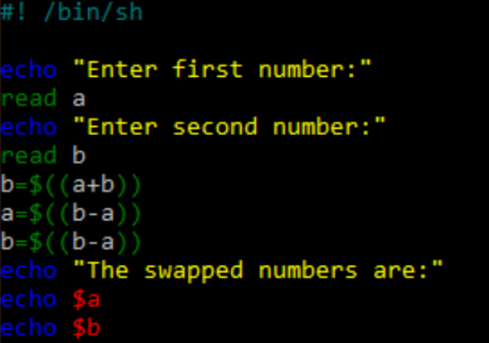

Output:
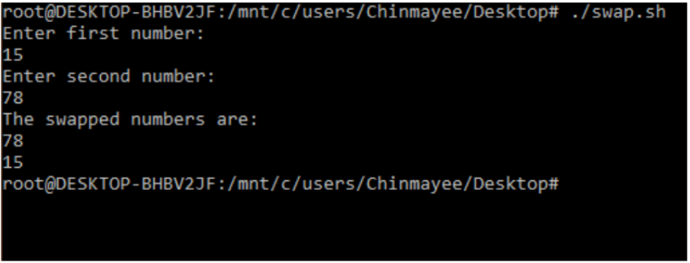
2) Find the sum of first ‘N’ numbers in Fibonacci Series
Code:

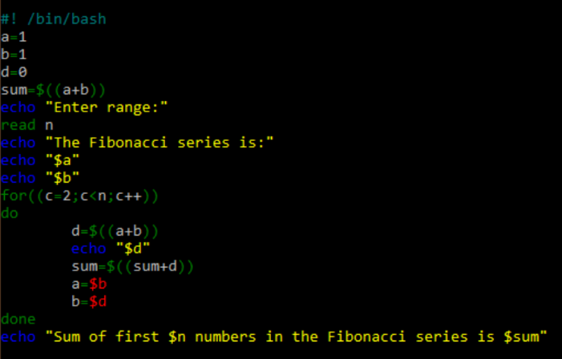

Output:
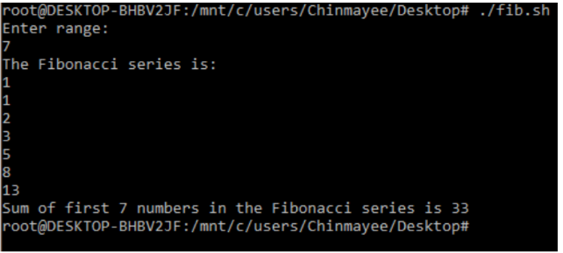

3) Print a given number in reverse order and
sum of the individual digits
Code:
3) Print a given number in reverse order and the sum of the individual digits
Code:
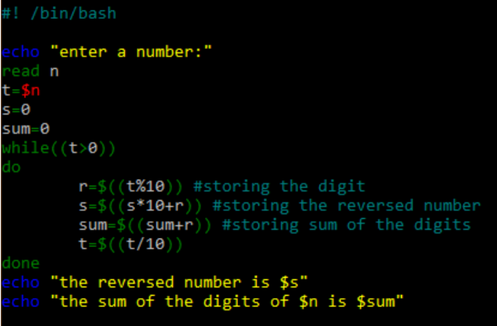

Output:
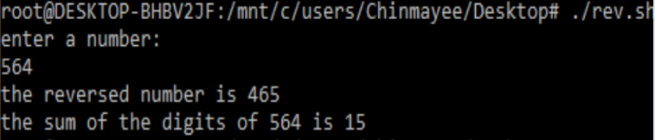

4) Read two strings and display whether it is
equal , not equal, null strings or string with
special characters
Code:
4) Read two strings and display whether it is equal not equal, null strings, or string with special characters
Code:
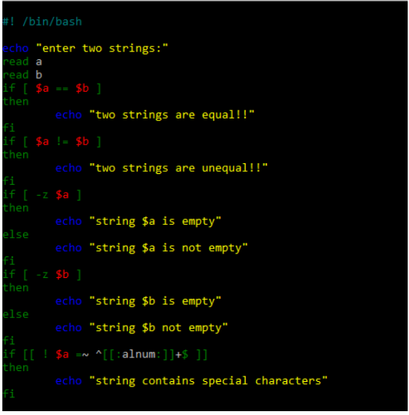
Output:
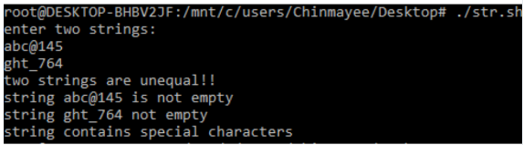
5) Accept one integer argument and print its multiplication table
Code:
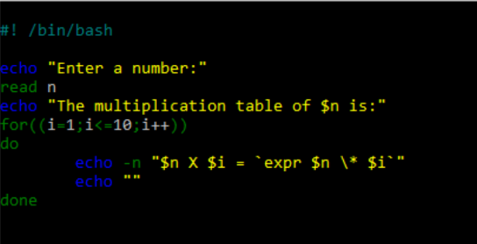
Output:
